Aire at Armley

|  |  |
| --- | --- |
| Rating Change Report | August 2016 |

Site Details

Station Number: F1707

River Name: Aire

Station Name: Armley

Grid Reference: SE 28057 34020

Station Datum: 26.06mAOD (in WISKI); 26.039 (old survey sheet in Hydrology file and previous location); 26.035mAOD (GPS survey by FMD in November 2012 and new location)

Bankfull Level: at least 5.43m stage (left hand bank wall prior to the new gauge location)

Mean Bed Level: -1.18m stage

Description of station:

The flow site is a velocity area station rated by a cableway spanning almost 30m at the section. It is confined by the canal embankment on the right hand bank (in excess of 11m high) and by a wall on the left hand bank. Bypassing is rare but can occur in the most severe conditions as shown in the December 2015 floods: water came out of the left hand bank approximately 0.8 miles upstream and travelled down Kirkstall Road towards the city centre.

The channel control is from the broad-crested weir located approximately 2km downstream set in the ‘Dark Arches’ under Leeds railway station. During 1971, the wooden crest to the weirs sustained damage and were removed in late 1977, lowering most of the crests by 12 inches. The crests were then reconstructed in 1978.

Review Recommendations

* Implement the new proposed ratings for their associated validity period.
* Ensure H&T monitor the river and note if the weed growth issue, which stopped in 2005, returns.
* Try and complete high flow gaugings to check the proposed top end to the ratings.
* Update the NFFS with the latest rating equations used within WISKI/SKED.

Proposed Changes to Rating

All five ratings assigned to Armley require changing. This is generally to ensure the top end estimates follow the hydraulic modelled flows as developed by ARUP, but also include slight improvements to the lower and mid level estimates.

1. Rating ‘A’: Winter rating

The current rating, 'A', will be replaced by a new rating, 'F', which has 3 limbs and equates to:

|  |  |  |  |
| --- | --- | --- | --- |
| Upper limit (m stage) | C | A | B |
| 0.685 | 30.69 | 0.156 | 1.115 |
| 1.917 | 27.884 | 0.028 | 1.462 |
| 4.17 | 30.127 | 0.153 | 1.502 |

using the formula of Q = C(h - a)B where h = stage and flow = Q. The upper limb values are not exactly the same as those produced by ARUP (which will follow for all five proposed new ratings) because the change point for the upper limb is lower. However, they still follow the curve developed by ARUP and produce the same flow estimates up to the rating limit.

The lower limb has a good correlation to the gaugings and the new rating follows this as closely as possible. Improvements have been made to the mid and upper flow estimates which has altered the change points of the limbs. Figures 1 and 2 compare the new rating to rating ‘A’.

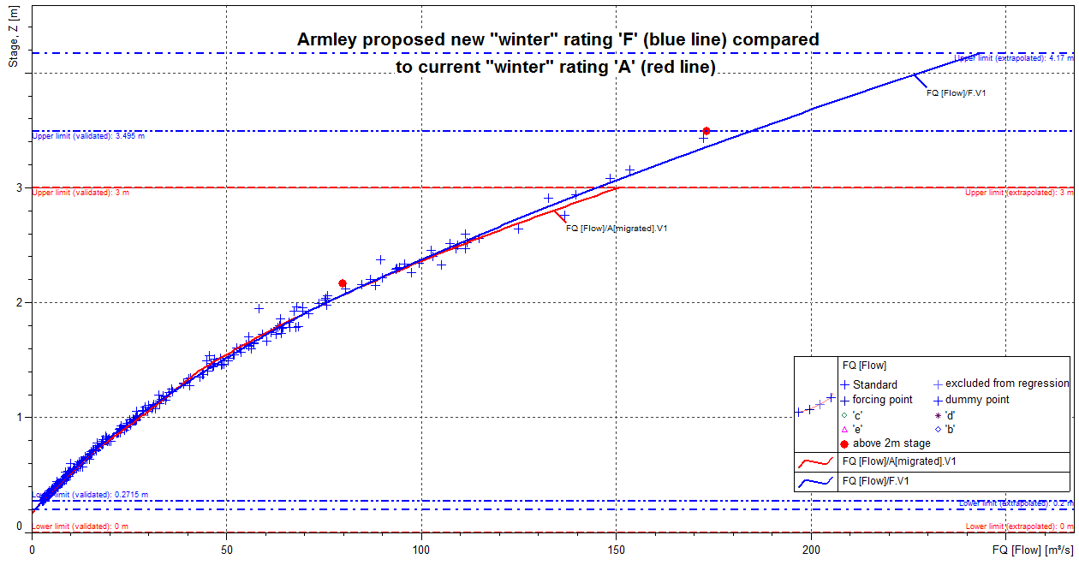

Figure 1: Armley proposed new “winter” rating ‘F’ (in blue) compared to current rating ‘A’ (in red), and gaugings assigned with the rating validity plus any others over 2m stage.

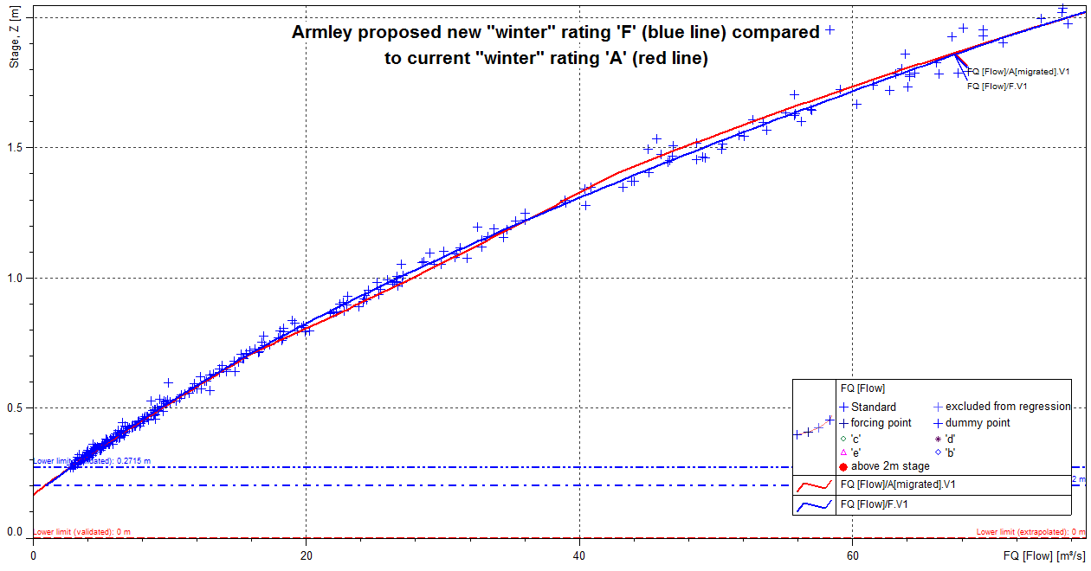

Figure 2: Armley proposed new “winter” rating ‘F’ (in blue) compared to current rating ‘A’ (in red), and gaugings assigned with the rating validity – low level close up.

The limit for the first limb has been reduced to 0.685m stage while the second limb increased to 1.917m stage. The lower limit has been stopped just below the lowest check gauging at 0.2m stage and the upper limit capped at 4.17m stage. Although this is above the highest check gauge, it correlates with the rating developed by ARUP and also corresponds to a change in cross section profile. To date, the recorded peak level is 5.217m stage during the December 2015 floods. The current rating 'A' has this peak flow as 403.17m3/s but the new rating 'F' would lower this to 344.43m3/s.

337 gaugings are assigned when rating ‘A’ is valid which also includes any others over 2m stage. For the current rating, the lower limb to 0.714m stage has a standard error (SE) of +/-5.39% with using 180 gaugings. Although the new rating has different limb sections, the lower limb to 0.685m stage contains 174 gaugings and has a SE of +/-5.42%. The second limb, to 1.396m stage, for the current rating has a SE of +/-4.18% using 74 gaugings while the new rating’s second limb, to 1.917m stage, has a SE of +/-3.44% using 122 gaugings. The third “extended beyond upper limit” limb for the current rating has a SE of +/-5.31% using 83 gaugings. These change to a SE of +/-5.28% for the new rating using 41 gaugings. Table 1 summarises these results.



Table 1: Standard Error comparisons for Armley current rating ‘A’ and proposed new “winter” rating ‘F’.

Regarding the deviation, the current “extended beyond upper limit” rating has a 43% positive (gauging suggests a higher flow than the rating) deviation and 57% negative deviation. The new rating changes to 55% positive deviation and 45% negative deviation. Figure 3 shows the deviation over time and stage for the new rating while figures 4 and 5 show the cumulative deviations over time and stage.

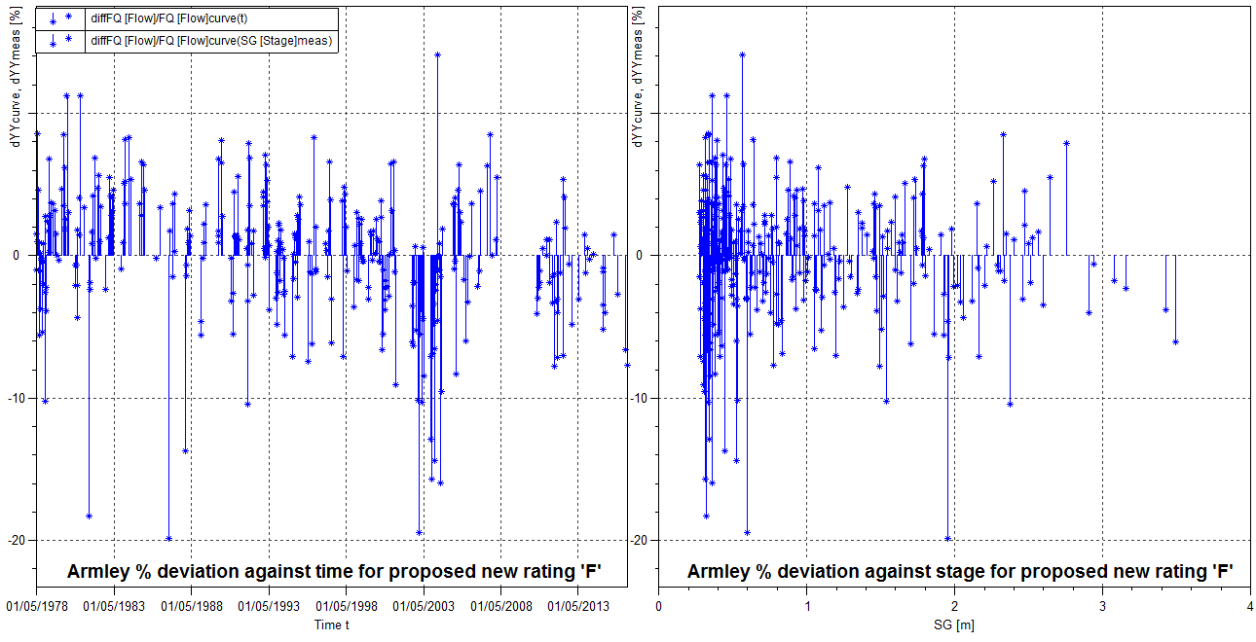

Figure 3: Armley new rating ‘F’ percentage deviation plots (gaugings assigned with the rating validity plus any others over 2m stage).

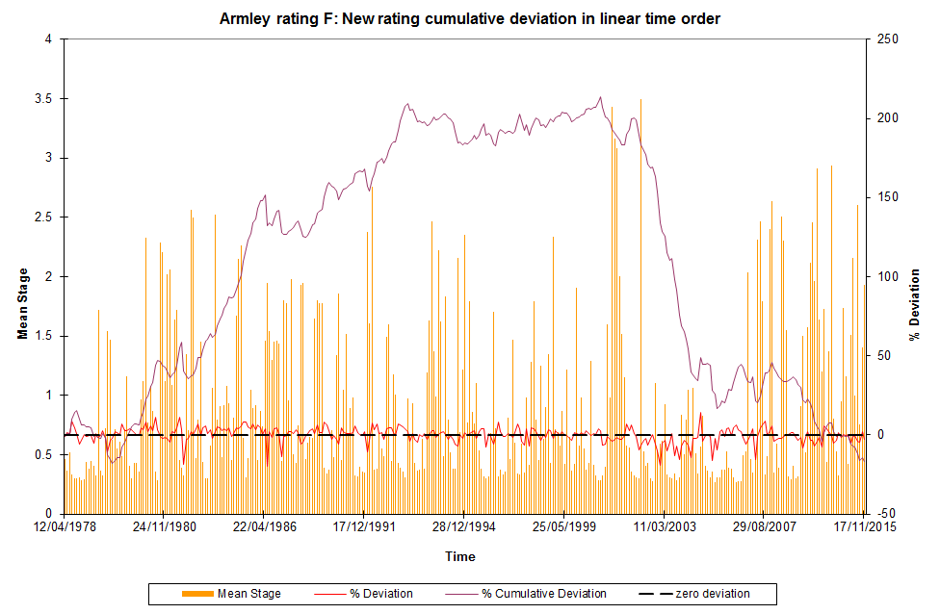

Figure 4. Armley new rating ‘F’ cumulative deviation, percentage deviation and mean recorded stage (linear time order) for gaugings assigned with the rating validity plus any others over 2m stage.

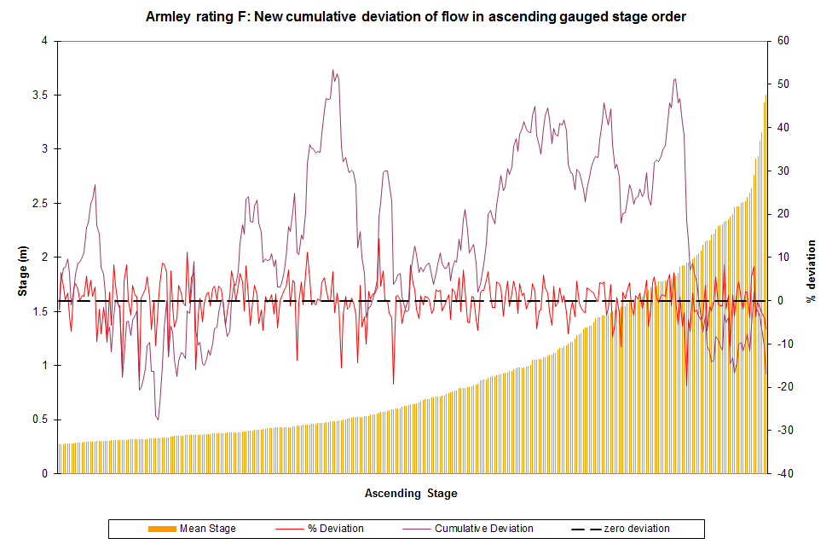

Figure 5. Armley new rating ‘F’ cumulative deviation, percentage deviation and mean recorded stage (ascending stage order) for gaugings assigned with the rating validity plus any others over 2m stage.

The GSDQ will not be updated using the proposed rating as all statistics required (period of record) would have to be calculated manually. Completing this will be time consuming and given the overall changes are small, it is assumed that the results will not be worse and if anything would improve slightly. This follows on for all subsequent rating changes.

Within SKED the new rating is labelled as “F” and version as “V1”.

1. Rating ‘B’: Spring/autumn rating

Rating 'B' will be replaced by a new rating, 'G', which has 4 limbs and equates to:

|  |  |  |  |
| --- | --- | --- | --- |
| Upper limit (m stage) | C | A | B |
| 0.591 | 28.068 | 0.152 | 1.156 |
| 1.221 | 29.113 | 0.114 | 1.335 |
| 2.258 | 8.016 | -0.64 | 2.295 |
| 4.170 | 30.127 | 0.153 | 1.502 |

using the formula of Q = C(h - a)B where h = stage and flow = Q.

In adding the ARUP top end limb onto rating ‘B’ and amending the lower limb to fit the gaugings better, it has meant that the overall rating has altered slightly. Figures 6 and 7 compare the new rating to rating ‘B’.

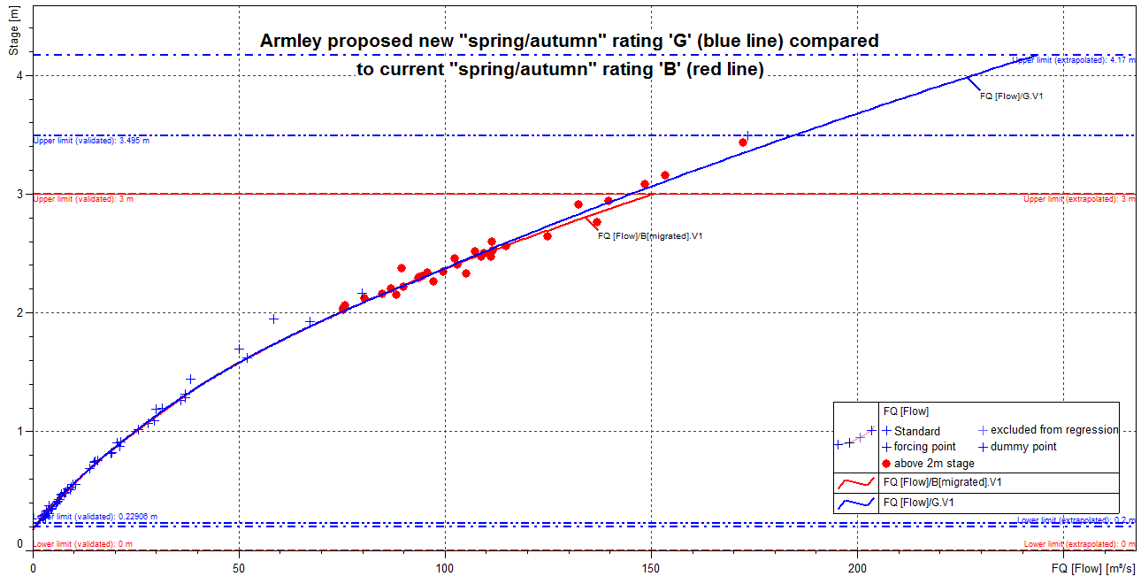

Figure 6: Armley proposed new “spring/autumn” rating ‘G’ (in blue) compared to current rating ‘B’ (in red), and gaugings assigned with the rating validity plus any others over 2m stage.

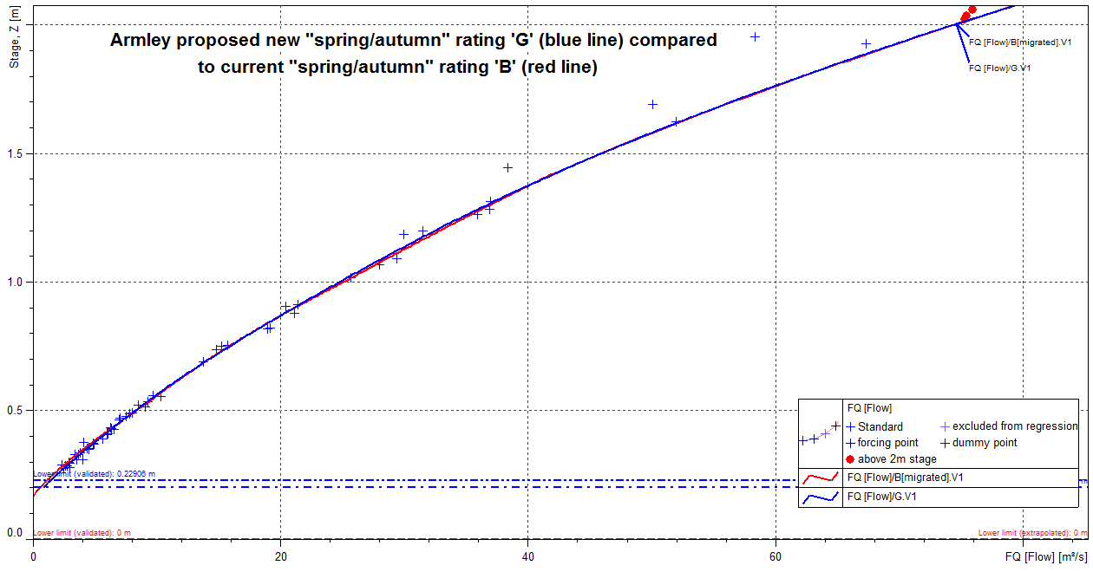

Figure 7: Armley proposed new “spring/autumn” rating ‘G’ (in blue) compared to current rating ‘B’ (in red), and gaugings assigned with the rating validity – low level close up.

The rating has now altered from five limbs to four limbs. The lower limit has been stopped just below the lowest check gauging at 0.2m stage and the upper limit capped at 4.17m stage (same as rating ‘F’ above).

91 gaugings are assigned when rating ‘B’ was valid which also includes any others over 2m stage. For the current rating, the lower limb to 0.536m stage has a SE of +/-11.07% with using 34 gaugings. Although the new rating has different limb sections, the lower limb to 0.591m stage contains 36 gaugings and has a SE of +/-7.36%. The second limb for the current rating, to 1.003m stage, contains 12 gaugings and has a SE of +/-3.76% and the third limb, to 1.416m stage, contains 7 gaugings so no calculations can be made. The

second limb for the new rating, to 1.221m stage, contains 14 gaugings and has a SE of +/-3.97%. The fourth limb for the current rating, to 2.78m stage, has 32 gaugings with a SE of +/-4.64% and the final extended limb has just 6 gaugings. For the new rating, the third limb to 2.258m stage contains 16 gaugings with a SE of +/-4.79% and the upper limb to 4.17m stage contains 25 gaugings with a SE of +/-4.49%. Table 2 summarises these results.



Table 2: Standard Error comparisons for Armley current rating ‘B’ and proposed new “spring/autumn” rating ‘G’.

Regarding the deviation, the current “extended beyond upper limit” rating has 46% positive deviation and 54% negative deviation. The new rating changes to 44% positive deviation and 56% negative deviation. Figure 8 shows the deviation over time and stage for the new rating while figures 9 and 10 show the cumulative deviations over time and stage.

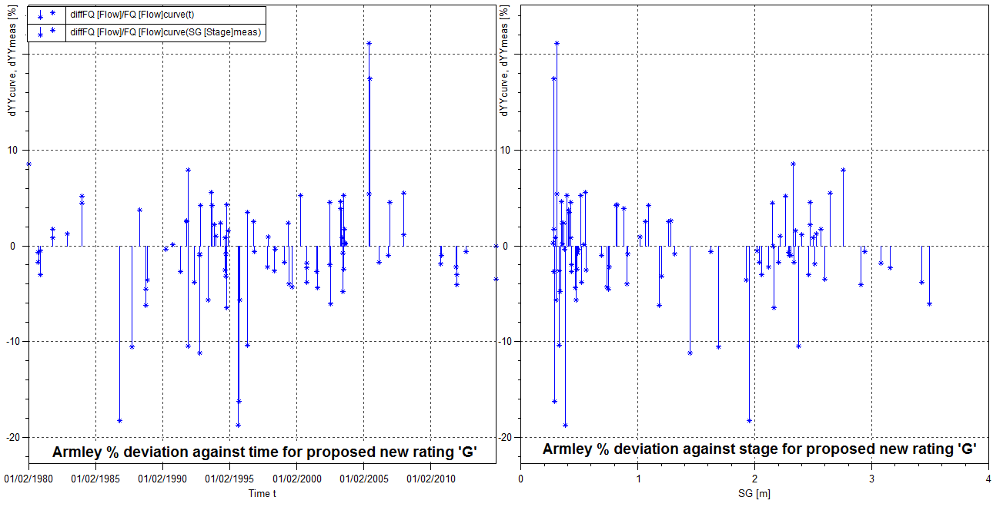

Figure 8: Armley new rating ‘G’ percentage deviation plots (gaugings assigned with the rating validity plus any others over 2m stage).

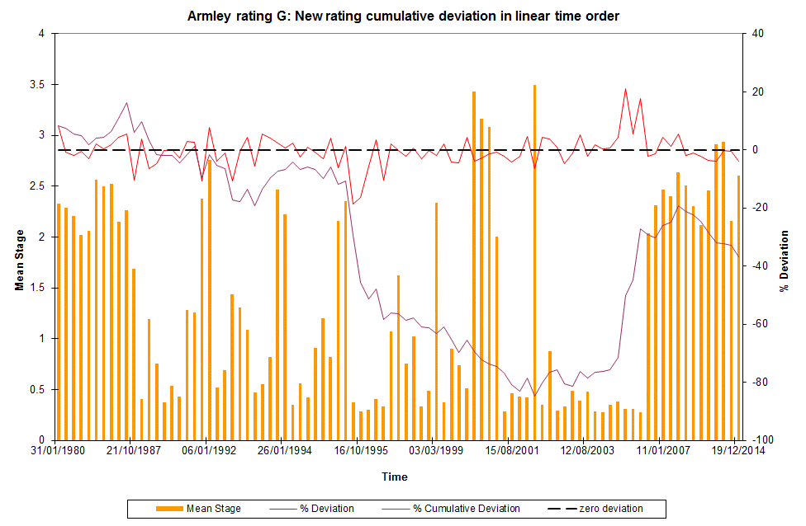

Figure 9. Armley new rating ‘G’ cumulative deviation, percentage deviation and mean recorded stage (linear time order) for gaugings assigned with the rating validity plus any others over 2m stage.

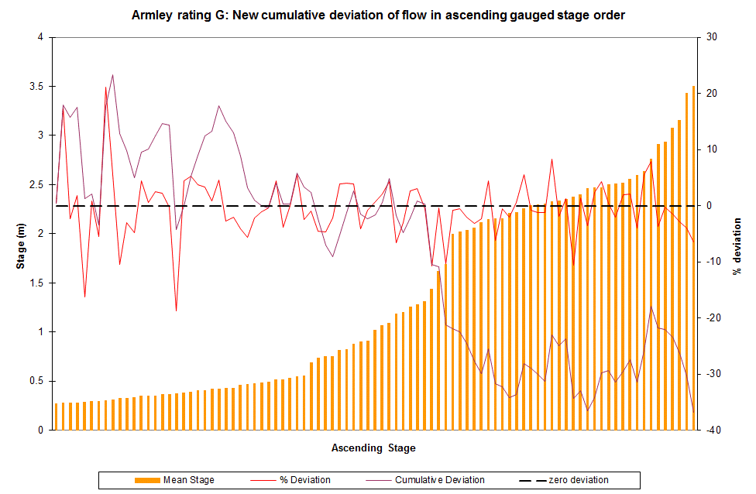

Figure 10. Armley new rating ‘G’ cumulative deviation, percentage deviation and mean recorded stage (ascending stage order) for gaugings assigned with the rating validity plus any others over 2m stage.

Within SKED the new rating is labelled as “G” and version as “V1”.

1. Rating ‘C’: Intermediate rating

Rating 'C' will be replaced by a new rating, 'H', which has 3 limbs and equates to:

|  |  |  |  |
| --- | --- | --- | --- |
| Upper limit (m stage) | C | A | B |
| 0.697 | 28.308 | 0.146 | 1.312 |
| 2.267 | 10.754 | -0.391 | 2.204 |
| 4.170 | 30.127 | 0.153 | 1.502 |

using the formula of Q = C(h - a)B where h = stage and flow = Q.

The overall rating has altered slightly as a result of adding the ARUP top end limb onto rating ‘C’ and amending the lower limb a little to fit the gaugings better. Figures 11 and 12 compare the new rating to rating ‘C’.

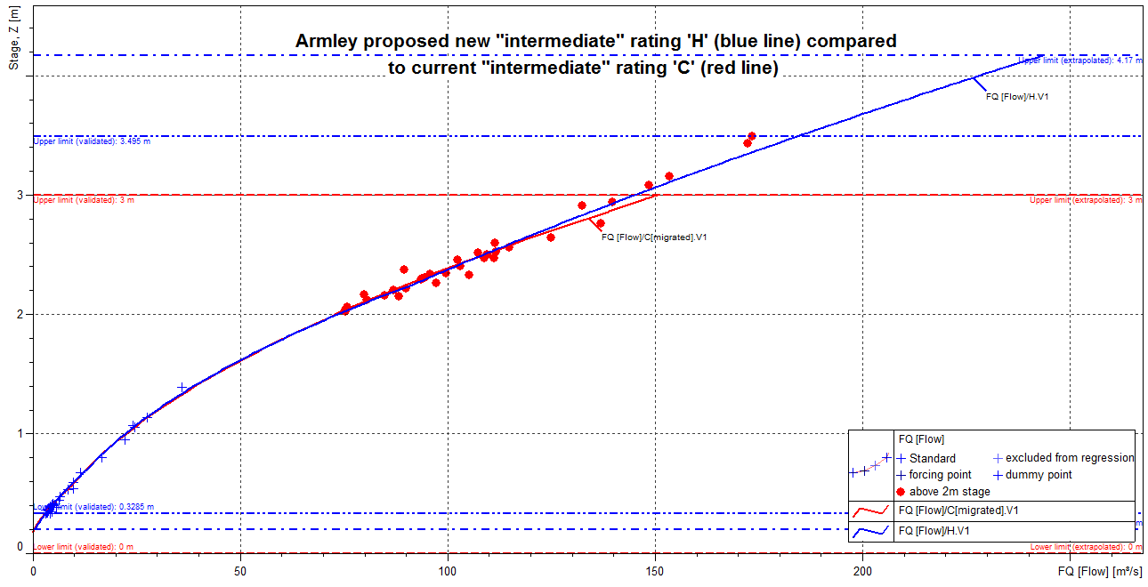

Figure 11: Armley proposed new “intermediate” rating ‘H’ (in blue) compared to current rating ‘C’ (in red), and gaugings assigned with the rating validity plus any others over 2m stage.

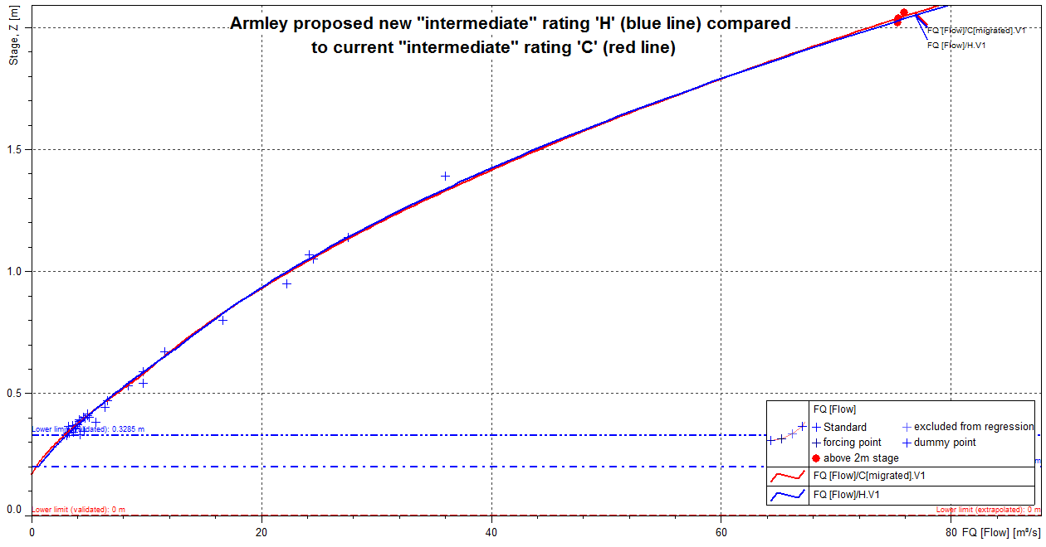

Figure 12: Armley proposed new “intermediate” rating ‘H’ (in blue) compared to current rating ‘C’ (in red), and gaugings assigned with the rating validity – low level close up.

The limit for the first limb has been extended to 0.697m stage while the second limb reduced to 2.267m stage. The lower limit has been stopped just below the lowest check gauging at 0.2m stage and the upper limit capped at 4.17m stage (same as rating ‘F’ above).

70 gaugings are assigned when rating ‘C’ was valid which also includes any others over 2m stage. For the current rating, the lower limb to 0.569m stage has a SE of +/-15.56% with using 27 gaugings. Although the new rating has different limb sections, the lower limb to 0.697m stage contains 29 gaugings and has a SE of +/-12.97%. The second limb for the current rating, to 2.861m stage, contains 37 gaugings and has a SE of +/-4.21% and the upper limb contains 6 gaugings so no calculations can be made. The second limb for the new rating, to 2.267m stage, contains 17 gaugings and has a SE of +/-3.98% and the upper limb contains 24 gaugings and has a SE of +/-4.43%. Table 3 summarises these results.



Table 3: Standard Error comparisons for Armley current rating ‘C’ and proposed new “intermediate” rating ‘H’.

Regarding the deviation, the current “extended beyond upper limit” rating has 61% positive deviation and 39% negative deviation. The new rating changes to 47% positive deviation and 53% negative deviation. Figure 13 shows the deviation over time and stage for the new rating while figures 14 and 15 show the cumulative deviations over time and stage.

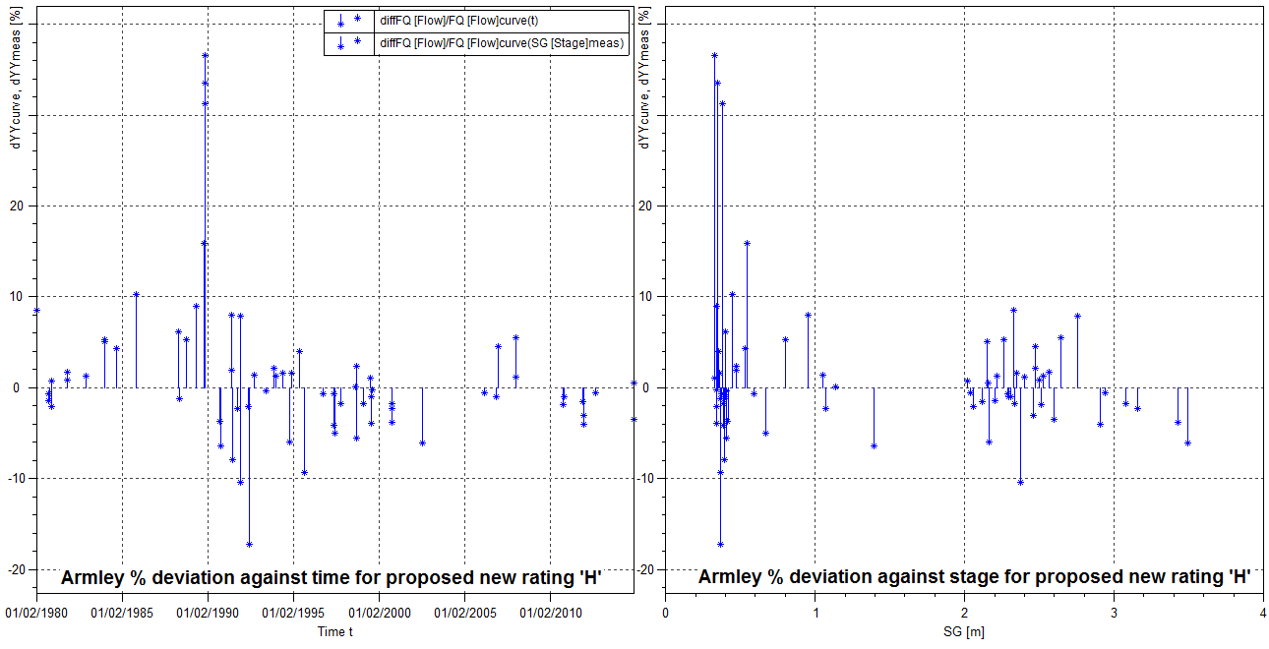

Figure 13: Armley new rating ‘H’ percentage deviation plots (gaugings assigned with the rating validity plus any others over 2m stage).

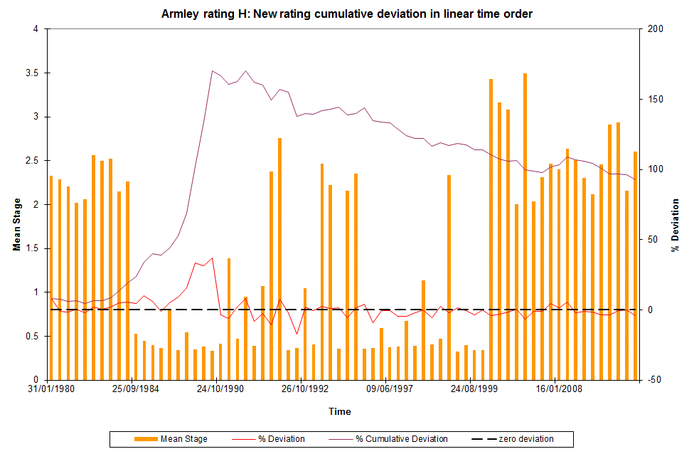

Figure 14. Armley new rating ‘H’ cumulative deviation, percentage deviation and mean recorded stage (linear time order) for gaugings assigned with the rating validity plus any others over 2m stage.

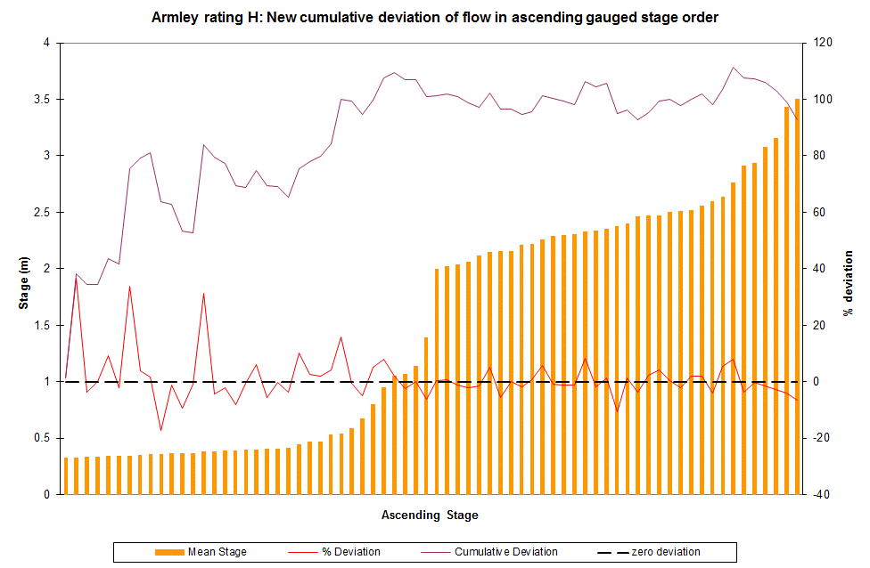

Figure 15. Armley new rating ‘H’ cumulative deviation, percentage deviation and mean recorded stage (ascending stage order) for gaugings assigned with the rating validity plus any others over 2m stage.

Within SKED the new rating is labelled as “H” and version as “V1”.

1. Rating ‘D’: Intersummer rating

Rating 'D' will be replaced by a new rating, 'I', which has 3 limbs and equates to:

|  |  |  |  |
| --- | --- | --- | --- |
| Upper limit (m stage) | C | A | B |
| 0.508 | 27.89 | 0.135 | 1.504 |
| 2.296 | 19.99 | -0.028 | 1.844 |
| 4.170 | 30.127 | 0.153 | 1.502 |

using the formula of Q = C(h - a)B where h = stage and flow = Q.

The overall rating has altered slightly as a result of adding the ARUP top end limb onto rating ‘D’ and amending the lower limb a little to fit the gaugings better. Figures 16 and 17 compare the new rating to rating ‘D’.

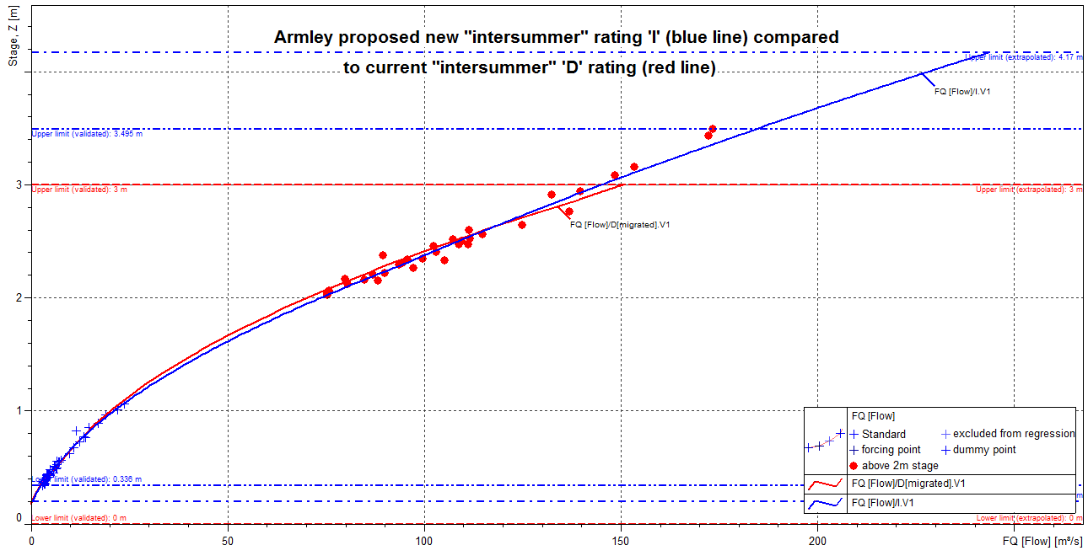

Figure 16: Armley proposed new “intersummer” rating ‘I’ (in blue) compared to current rating ‘D’ (in red), and gaugings assigned with the rating validity plus any others over 2m stage.

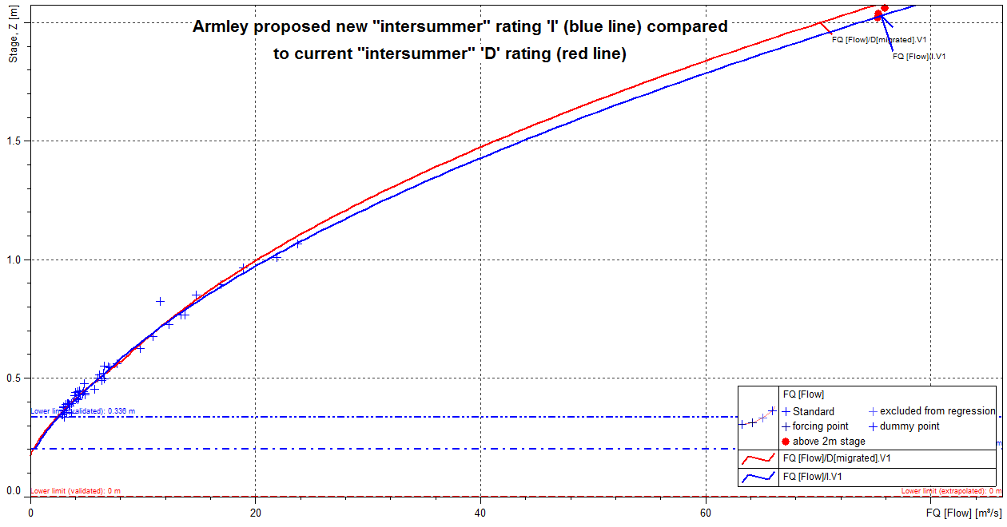

Figure 17: Armley proposed new “intersummer” rating ‘I’ (in blue) compared to current rating ‘D’ (in red), and gaugings assigned with the rating validity – low level close up.

Both first and second limb limits have been lowered while the lower limit has been stopped just below the lowest check gauging at 0.2m stage and the upper limit capped at 4.17m stage (same as rating ‘F’ above).

88 gaugings are assigned when rating ‘D’ was valid which also includes any others over 2m stage. For the current rating, the lower limb to 0.584m stage has a SE of +/-10.28% with using 42 gaugings. Although the new rating has different limb sections, the lower limb to 0.508m stage contains 36 gaugings and has a SE of +/-9.74%. The second limb for the current rating, to 2.868m stage, contains 40 gaugings and has a SE of +/-6.05% and the upper limb contains 6 gaugings so no calculations can be made. The second limb for

the new rating, to 2.296m stage, contains 29 gaugings and has a SE of +/-5.85% and the upper limb contains 23 gaugings and has a SE of +/-4.53%. Table 4 summarises these results.



Table 4: Standard Error comparisons for Armley current rating ‘D’ and proposed new “intersummer” rating ‘I’.

Regarding the deviation, the current “extended beyond upper limit” rating has 61% positive deviation and 39% negative deviation. The new rating changes to 47% positive deviation and 53% negative deviation. Figure 18 shows the deviation over time and stage for the new rating while figures 19 and 20 show the cumulative deviations over time and stage.

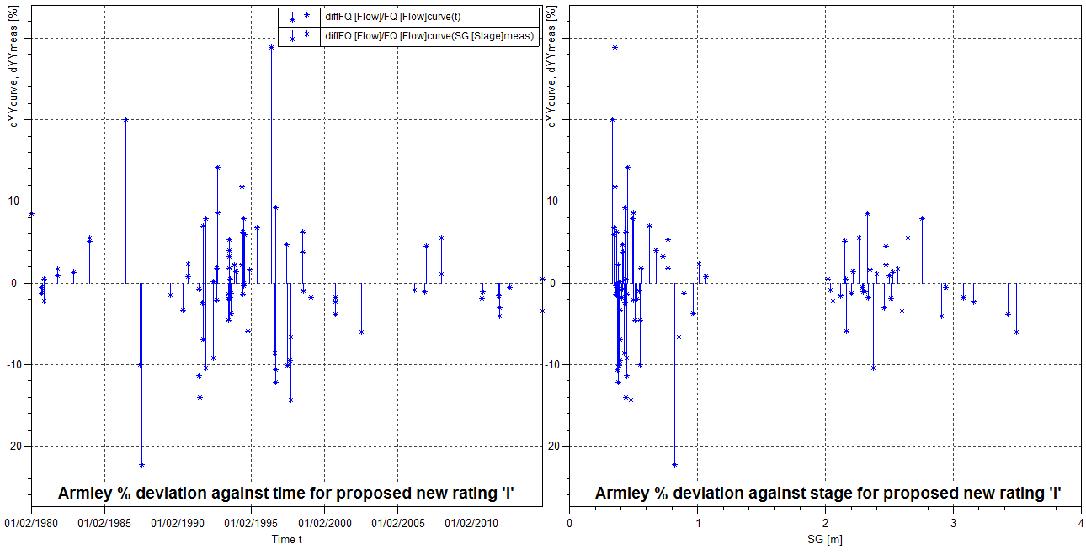

Figure 18: Armley new rating ‘I’ percentage deviation plots (gaugings assigned with the rating validity plus any others over 2m stage).

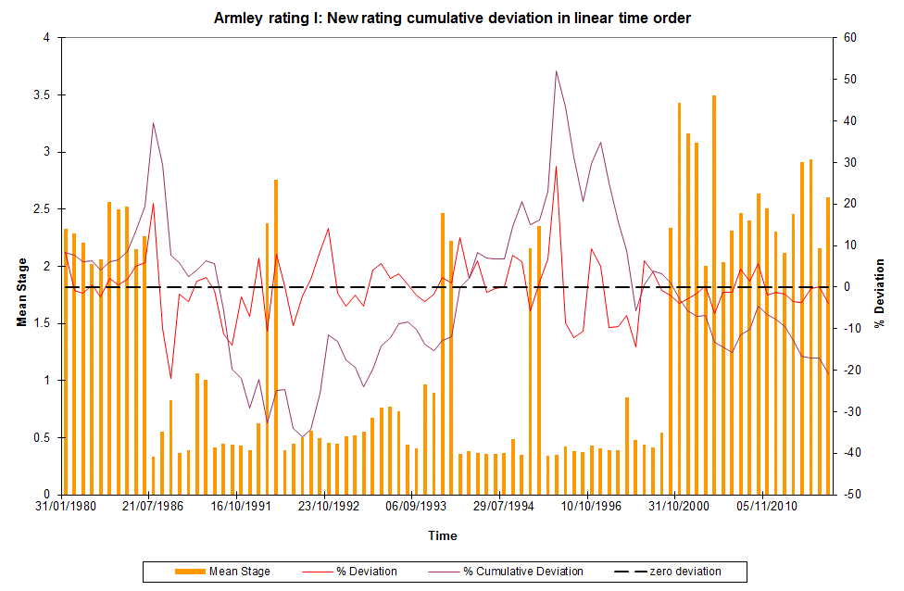

Figure 19. Armley new rating ‘I’ cumulative deviation, percentage deviation and mean recorded stage (linear time order) for gaugings assigned with the rating validity plus any others over 2m stage.

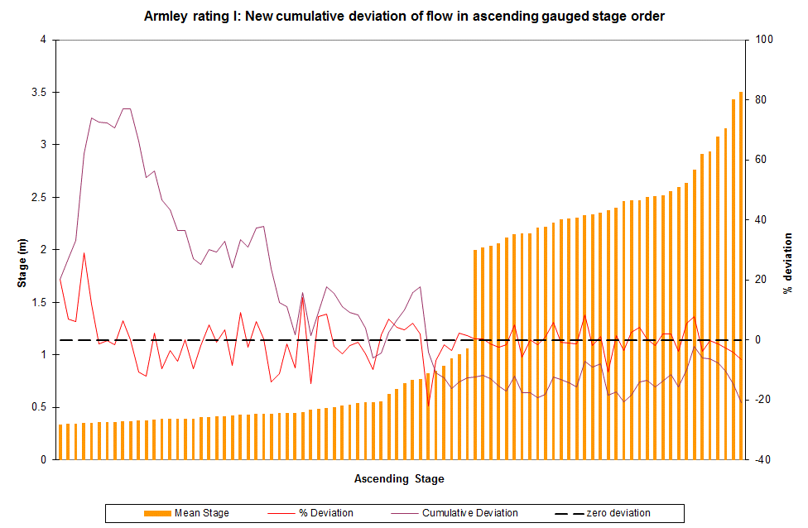

Figure 20. Armley new rating ‘I’ cumulative deviation, percentage deviation and mean recorded stage (ascending stage order) for gaugings assigned with the rating validity plus any others over 2m stage.

Within SKED the new rating is labelled as “I” and version as “V1”.

1. Rating ‘E’: Summer rating

Rating 'E' will be replaced by a new rating, 'J', which has 3 limbs and equates to:

|  |  |  |  |
| --- | --- | --- | --- |
| Upper limit (m stage) | C | A | B |
| 0.628 | 27.485 | 0.12 | 1.75 |
| 2.265 | 7.795 | -0.402 | 2.523 |
| 4.170 | 30.127 | 0.153 | 1.502 |

using the formula of Q = C(h - a)B where h = stage and flow = Q.

The rating has altered above approximately 0.6m stage. The new rating fits better to the gaugings above 2m stage and has the new top end proposed by ARUP. Figures 21 and 22 compare the new rating to rating ‘E’.

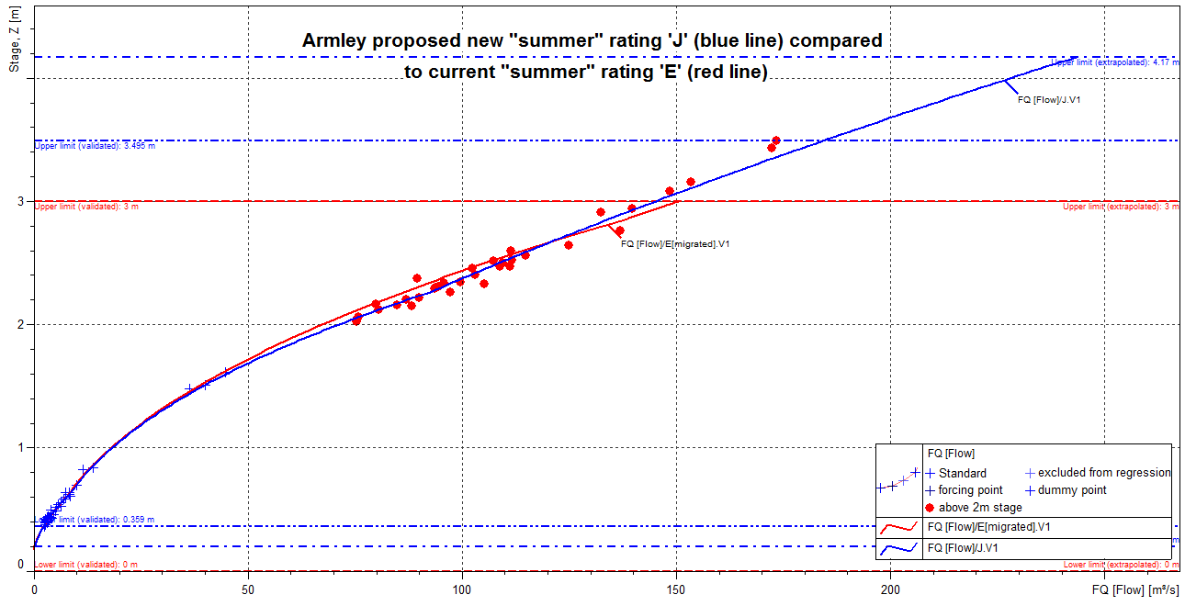

Figure 21: Armley proposed new “summer” rating ‘J’ (in blue) compared to current rating ‘E’ (in red), and gaugings assigned with the rating validity plus any others over 2m stage.

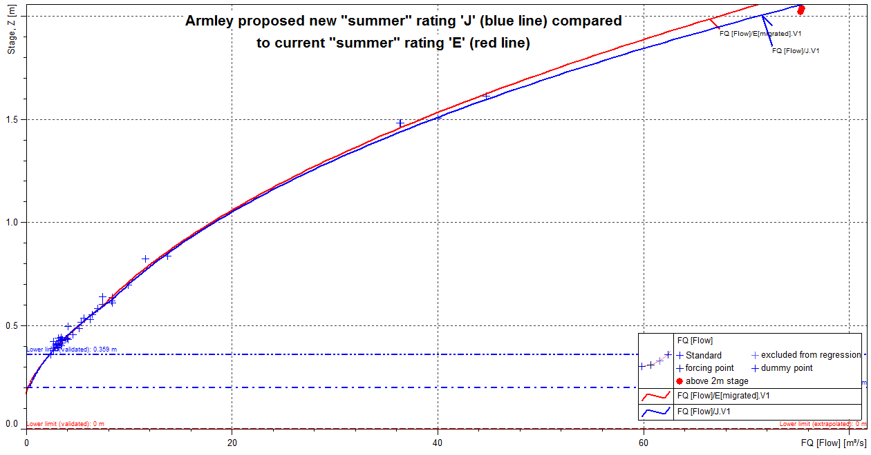

Figure 22: Armley proposed new “summer” rating ‘J’ (in blue) compared to current rating ‘E’ (in red), and gaugings assigned with the rating validity – low level close up.

The limit for the first limb has been extended to 0.628m stage while the second limb reduced to 2.265m stage. The lower limit has been stopped just below the lowest check gauging at 0.2m stage and the upper limit capped at 4.17m stage (same as rating ‘F’ above).

78 gaugings are assigned when rating ‘E’ was valid which also includes any others over 2m stage. For the current rating, the lower limb to 0.596m stage has a SE of +/-9.07% with using 32 gaugings. Although the new rating has different limb sections, the lower limb to 0.628m stage contains 35 gaugings and has a SE of +/-8.68%. The second limb for the current rating, to 2.861m stage, contains 40 gaugings and has a SE of +/-6.93% and the upper limb contains 6 gaugings so no calculations can be made. The second limb for the new rating, to 2.265m stage, contains 19 gaugings and has a SE of +/-4.86% and the upper limb contains 24 gaugings and has a SE of +/-4.43%. Table 5 summarises these results.



Table 5: Standard Error comparisons for Armley current rating ‘E’ and proposed new “summer” rating ‘J’.

Regarding the deviation, the current “extended beyond upper limit” rating has 64% positive deviation and 36% negative deviation. The new rating changes to 51% positive deviation and 49% negative deviation. Figure 23 shows the deviation over time and stage for the new rating while figures 24 and 25 show the cumulative deviations over time and stage.

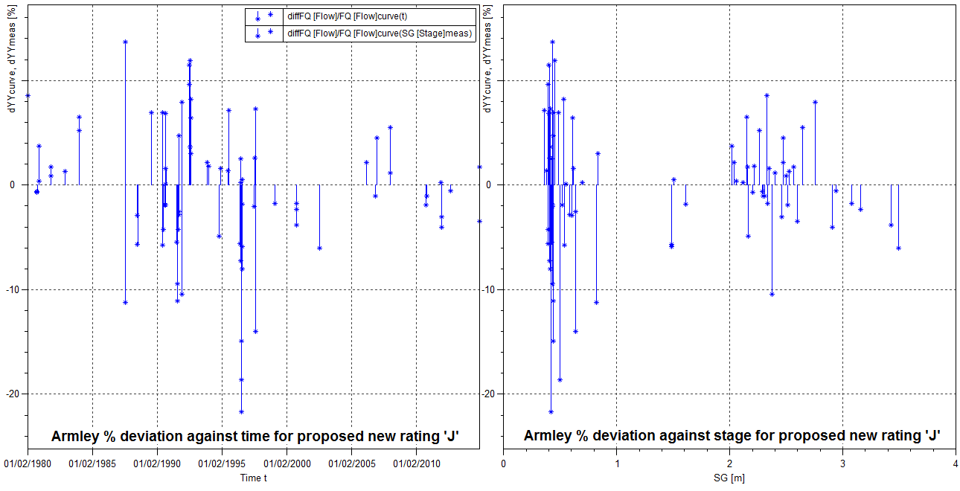

Figure 23: Armley new rating ‘J’ percentage deviation plots (gaugings assigned with the rating validity plus any others over 2m stage).

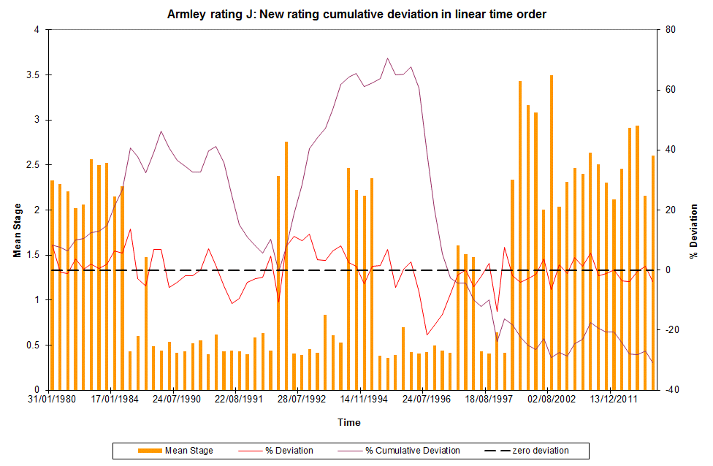

Figure 24. Armley new rating ‘J’ cumulative deviation, percentage deviation and mean recorded stage (linear time order) for gaugings assigned with the rating validity plus any others over 2m stage.

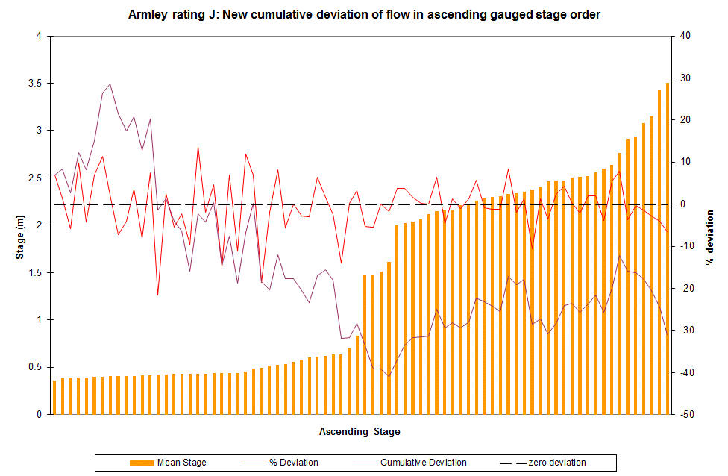

Figure 25. Armley new rating ‘J’ cumulative deviation, percentage deviation and mean recorded stage (ascending stage order) for gaugings assigned with the rating validity plus any others over 2m stage.

Within SKED the new rating is labelled as “J” and version as “V1”.

Further Work Recommended

As long as the weed growth issue does not return, no further action is required for ratings ‘G’ to ‘J’. Should the weed become an issue again, then the appropriate ratings need to be implemented for the relevant time periods and check gauged to see that they are performing well.

Rating ‘F’ will now be the rating used for Armley and the gauging requirements will be set out annually at the requirements meeting. Along with this, capturing the high flow is required in order to see how the top end is performing. The rating will be re-assessed in a few years time.

Approval and Sign Off

|  |  |  |  |  |
| --- | --- | --- | --- | --- |
| Rating change developed by: | | | | |
| Team | Name | Job Title | Signature | Date |
| Hydrology | Brian Leigh | Technical Officer 1 |  | 16/08/2016 |

|  |  |  |  |  |
| --- | --- | --- | --- | --- |
| Rating change approved by: | | | | |
| Team | Name | Job Title | Signature | Date |
| Hydrology | David Lindsay | Technical Specialist |  | 13/10/2016 |
| H&T |  |  |  |  |

|  |  |  |  |  |
| --- | --- | --- | --- | --- |
| Rating change implemented in Wiski by: | | | | |
| Team | Name | Job Title | Signature | Date |
| H&T |  |  |  |  |

|  |  |  |
| --- | --- | --- |
| Revised rating distributed to the following people: | | |
| Team | Name | Job Title |
|  |  |  |